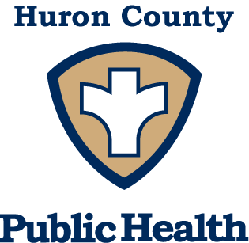
Huron County School Absentee Surveillance

Online reporting

School Absentee Surveillance is a way to track illness in schools and the community for individuals that may not see a doctor. Absentee surveillance benefits schools because it can be used to identify suspicious health events in your school or school districts.
Online School Absentee Surveillance System:
- Schools enter directly into the website which takes less than 5 minutes a day.
- Information is entered daily.
- Symptoms are tracked which are better for identifying illness.
- Data can be checked daily with minimal effort.
What information do we collect?
- Information on symptoms (cough, fever, rash, etc.).
- Information collected is aggregated and completely confidential.
- We DO NOT collect names, ages, genders, or any other identifiable information.
How do we collect the information?
- School staff will spend less than 5 minutes daily entering data into an online Survey. Using the link www.huroncohealth.com/school-absentee-surveillance Click on the School Data Entry button. You should be directed to a SurveyMonkey survey.
- Staff will use laminated reporting sheets and a whiteboard marker to tally absent children’s symptoms.
- Parents will be asked to VOLUNTEER their child’s symptoms. Parents are not required to participate.
There will be NO COST to schools except for 5 minutes of staff time for data entry and time for training.
If interested in electronic absentee reporting contact Melissa Caranfa at (419) 668-1652 ext. 269 or mcaranfa@huroncohealth.com.

